**MEDIAN FILTER**

clc

clear all

close

a=imread('C:\Users\fy\Desktop\coins.png')

an=imnoise(a,'salt & pepper',0.05)

an=double(an)

b=an

[r c]=size(a)

for i=1:r-2

for j=1:c-2

t1=an(i,j)

t2=an(i,j+1)

t3=an(i,j+2)

t4=an(i+1,j)

t5=an(i+1,j+1)

t6=an(i+1,j+2)

t7=an(i+2,j)

t8=an(i+2,j+1)

t9=an(i+2,j+2)

t=[t1 t2 t3 t4 t5 t6 t7 t8 t9]

ta=gsort(t)

b(i+1,j+1)=ta(5)

end

end

B=[an b]

imshow(uint8(B))

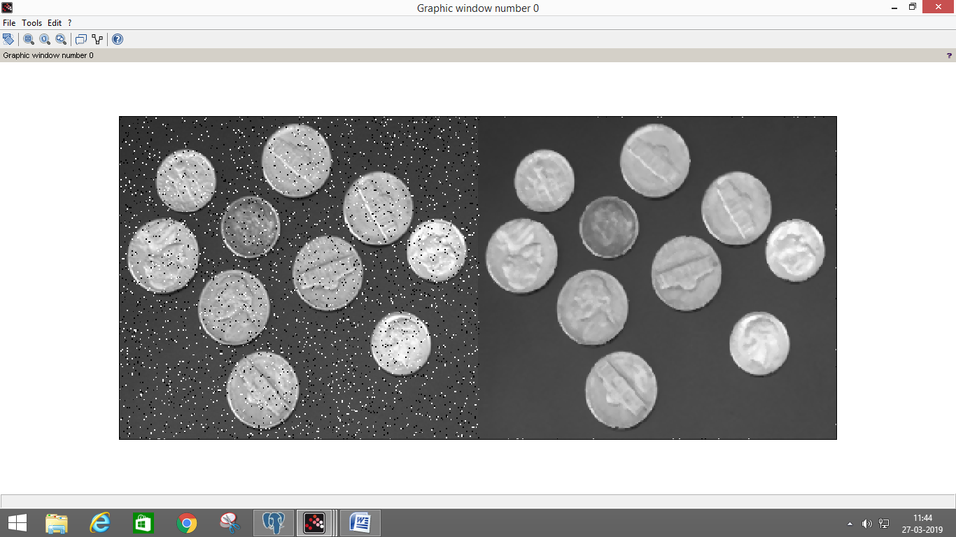

**GEOMETRIC MEAN FILTER**

**clc**

clear all

close

a=imread('C:\Users\fy\Desktop\coins.png')

an=imnoise(a,'gaussian',0.1)

an=double(an)

g=an

[r c]=size(an)

for x=2:1:r-1

for y=2:1:c-1

g(x,y)=(an(x-1,y-1)*an(x-1,y)*an(x-1,y+1)*an(x,y-1)*an(x,y)*an(x,y+1)*an(x+1,y-1)*an(x+1,y)*an(x+1,y+1))^(1/(9));

end

end

figure,imshow(uint8(an))

figure,imshow(uint8(g))

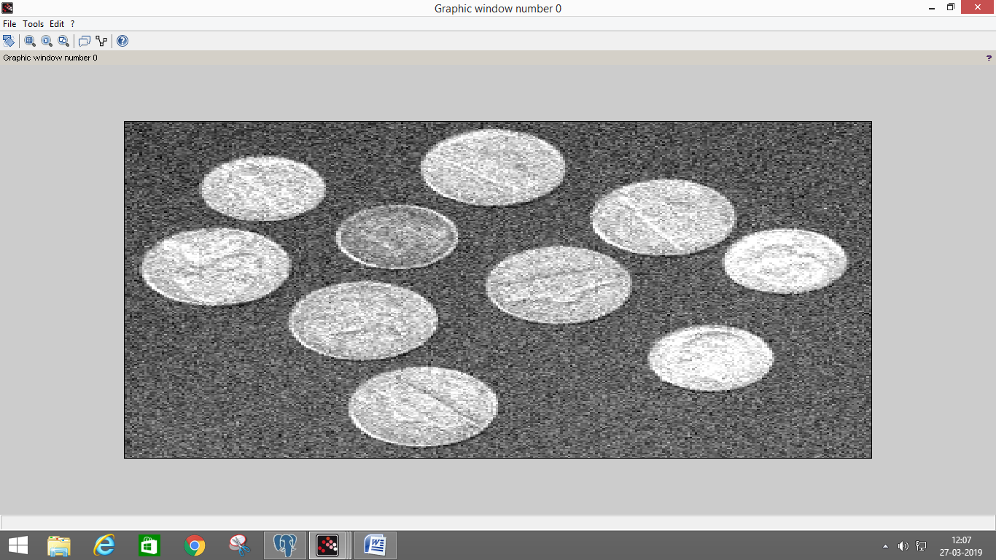

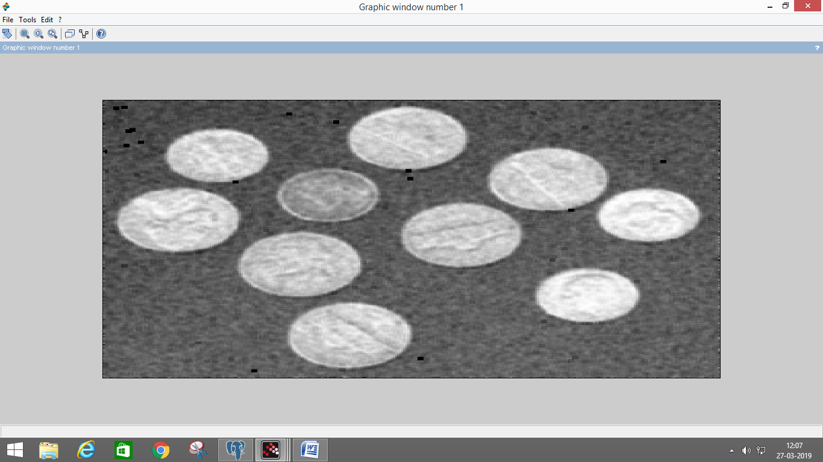

**Arithmetic mean filter**

clc

clear all

close

a=imread('C:\Users\fy\Desktop\coins.png')

an=imnoise(a,'arithmetic',0,0.1)

an=double(an)

g=an

w=(1/9)*[1 1 1;1 1 1;1 1 1]

[r c]=size(an)

for x=2:1:r-1

for y=2:1:c-1

g(x,y)=(an(x-1,y-1)*w(1)+an(x-1,y)*w(2)+an(x-1,y+1)*w(3)+an(x,y-1)*w(4)+an(x,y)*w(5)+an(x,y+1)*w(6)+an(x+1,y-1)*w(7)+an(x+1,y)*w(8)+an(x+1,y+1)*w(9));

end

end

figure,imshow(uint8(an))

figure,imshow(uint8(g))

